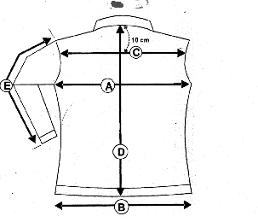VESTE JULIA GABARDINE
F
COTON

B

JULIA MARRON | 0 | XS | S | M | L | XL | XXL
B ½ taille |  | 36.5 | 38.5 | 40.5 | 42.5 | 46.5 | 48.5
A/ ½ Tour poitrine | 0 | 41.5 | 43.5 | 45.5 | 47.5 | 49.5 | 51.5
C/ Carrure dos | 0 | 34 | 37 | 38 | 38.5 | 39.5 | 41.5
D/ Longueur dos | 0 | 58 | 59.5 | 62.5 | 63.5 | 65.5 | 67.5
E/ Longueur manche | 0 | 60.5 | 61.5 | 62.5 | 63.5 | 64.5 | 65.5

