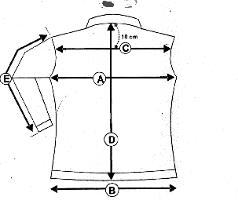VESTE IRINA
F

G

 | VESTE IRINA | XS | S | M | L | XL |  |  |  | XXL
 |  | 36 | 38 | 40 | 42 |  | 44 |  | 46
A | LARGEUR POITRINE | 50 | 52 | 54 | 56 |  | 58 | 60
D | LONGUEUR DOS | 67.5 | 67.5 | 69 | 69 |  | 70 | 70
E | LONGUEUR MANCHE | 64.5 | 64.5 | 65 | 65 |  | 65 | 65
F | LARGEUR SOUS POITRINE | 53 | 55 | 55 | 57 |  | 59 | 61
G | LARGEUR BAS | 58 | 60 | 62 | 65 |  | 67 | 70

Coloris: GRIS

Tailles: XS / XXL

