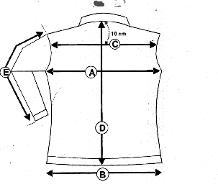Veste Grace Bi-Extensible
F

B

Grace 1 | XXS | XS | S | M | L | XL | XXL
cm
A/ ½ Tour poitrine | 39 | 41 | 45 | 49 | 52 | 53.5 | 54
C/ Carrure dos | 33 | 35 | 37 | 39 | 40 | 41 | 42
D/ Longueur dos | 61 | 62 | 63 | 64 | 65 | 66 | 67
E/ Longueur manche | 60.3 | 61.3 | 62.3 | 63.3 | 64.3 | 65.3 | 66

