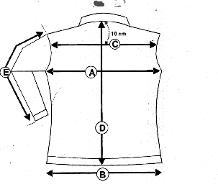VESTE JULIA JEAN’S
F

B

JULIA JEAN’S | 0 | XS | S | M | L | XL | XXL
B ½ taille |  | 36 | 38 | 40 | 42 | 46 | 48
A/ ½ Tour poitrine | 0 | 41 | 43 | 45 | 47 | 49 | 51
C/ Carrure dos | 0 | 33.5 | 36.5 | 37.5 | 38 | 39.5 | 41
D/ Longueur dos | 0 | 61 | 63 | 66 | 67 | 69 | 71
E/ Longueur manche | 0 | 61.5 | 62.5 | 63.5 | 64.5 | 65.5 | 66.5

