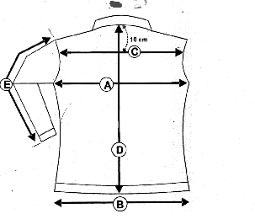VESTE VICTORIA
F

G

 | VESTE VICTORIA | XS | S | M | L | XL |  |  |  | XXL
 |  | 36 | 38 | 40 | 42 |  | 44 |  | 46
A | LARGEUR POITRINE | 49 | 51 | 53 | 55 |  | 57 | 60
D | LONGUEUR DOS | 68 | 68 | 69 | 69 |  | 70 | 70
E | LONGUEUR MANCHE | 64.5 | 64.5 | 65 | 65 |  | 65 | 65
F | LARGEUR EPAULES (CARRURE) | 40.5 | 41.5 | 42.5 | 44 |  | 45 | 45.5
G | LARGEUR BAS | 58 | 60 | 62 | 65 |  | 67 | 70

Coloris: choco/noir/camel

Tailles: XS / XXL

