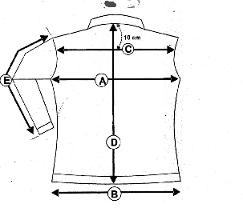Veste VICTOIRE
F
Bi-extensible

B

victoire 1 |  | XS | S | M | L | XL | XXL
cm
A/ ½ Tour poitrine |  | 42.5 | 44.5 | 46.5 | 48.5 | 50.5 | 52
C/ Carrure dos |  | 35 | 37 | 39 | 40 | 41 | 42
D |  | 71.5 | 72 | 72.5 | 73 | 73.5 | 73.5
E/ Longueur manche |  | 61.3 | 62.3 | 63.3 | 64.3 | 65 | 65

